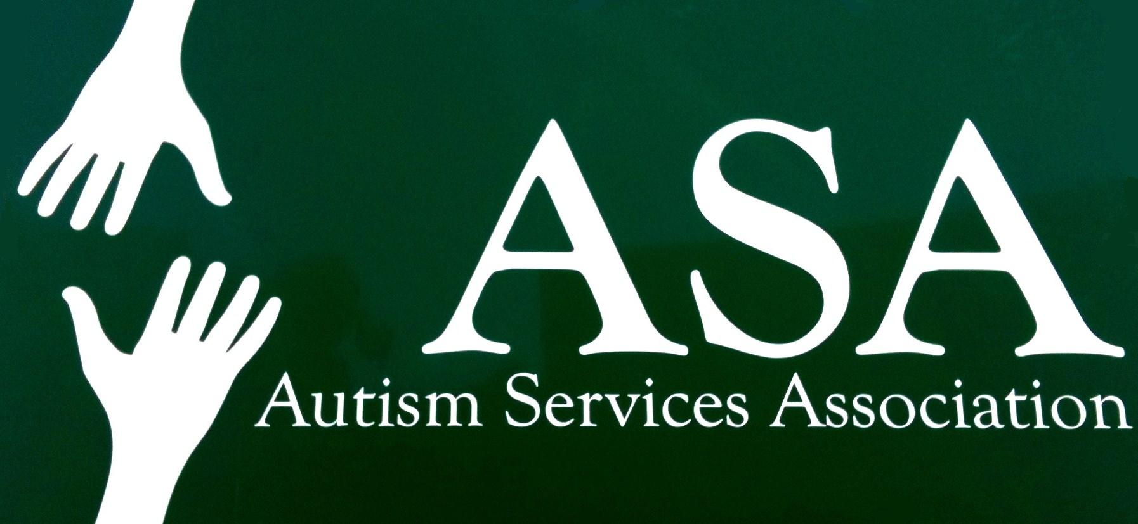 Autism Services Association, Inc.
47 Walnut Street, Wellesley Hills, MA 02481
TEL: (781) 237-0272 Fax: (781) 237-5020
E-Mail: sheelaasa@autismservicesassociation.org
Website: www.autismservicesassociation.org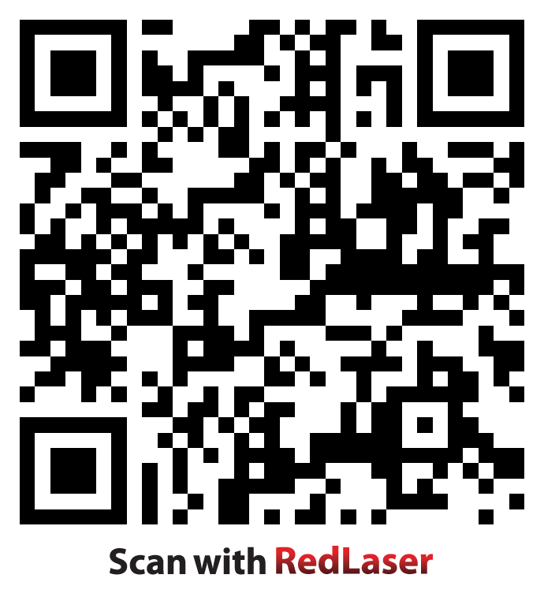

Information, Referral, Education, Supported Employment and Rehabilitation Services
Serving Central and Eastern Massachusetts

AUTISM SERVICES ASSOCIATION (ASA)

CODE OF CONDUCT January 2016

Purpose:

Autism Services Association (ASA)’ mission is to provide programs and services to people with disabilities that will enhance their independence. The purpose of a code of conduct is to provide guidelines for everyone involved with Autism Services Association (ASA) that will help them achieve their part of the organization’s mission in an efficient, effective and ethical manner. Everyone involved in providing programs and services, whether they are staff members, Board members or volunteers, is expected to understand and adhere to this Code.

Guiding Principle:

The guiding principle is that all people, including staff members, consumers, Board members and all others, are to be treated with dignity, respect, honesty and courtesy at all times. Each individual needs to be as aware of how the other person might feel as he/she is aware of how he/she feels in the course of the interaction.

- General Conduct

Job performance reviews for staff will be held on a regular basis. While the review focuses specifically on the job description, there are some aspects of job related behavior that are generally expected regardless of position. These include, but are not limited to:

- All staff are expected to adhere to company standards as defined in the Personnel Policies in regard to attendance and punctuality. In general, absences may not exceed the number of days that the individual earns: sick, vacation and personal.
- All staff are expected to manage time to achieve goals. They are expected to manage their time independently in cooperation with other staff or consumers.
- All staff are expected to possess and use adequate communication skills with staff, consumers, customers, other professionals. They are expected to communicate face-to-face and to be honest and open with each other.
- All staff represent the organization to the public. They are expected to create a good impression in regard to dress, demeanor, appearance, language, etc.
- All staff are expected to treat consumers with respect and dignity. Abuse of any kind will not be tolerated.
- All staff are expected to use paid time off prudently and appropriately. Paid time off is earned and designed to be used, but not abused. Abuse consists of waiting until the last minute to request time off consistently, not keeping track of time and having to take it on the spur of the moment to avoid losing it, etc.
- All staff are expected to be able to deal appropriately with the demands of the work environment. The work environment changes regularly and things don’t always go as planned. People are expected to be flexible and deal with the changes that occur without losing their professional attitude.
- All staff are expected to be a productive team member. Many work assignments within the organization operate as teams and each staff member is expected to be a productive member of the team to which he/she belongs or is assigned.

All employees and Board members will conduct themselves in a professional, courteous manner at all times when interacting with consumers, customers, other professionals involved with consumers, the public or each other.

Compliance with Applicable Laws and Company Policy:

Autism Services Association (ASA) staff and Board members are expected to
be familiar with all laws and regulations, as well as ASA policies, as they relate to the duties
and responsibilities associated with different jobs and roles. It is the responsibility of Autism
Services Association (ASA)’ management to provide basic information to all staff, consumers,
and Board members. It is the responsibility of staff members, consumers to seek guidance from
their supervisors in situations where boundaries, roles or responsibilities are unclear. It is the
responsibility of coordinators/supervisors to seek guidance from each other,
and the Executive Director. It is the responsibility of the Board to hold appropriate discussions,
and to make clear decisions regarding situations that require clarification. Some laws and policies
must be understood and adhered to by everyone associated with ASA. Common laws and
policies include but are not limited to, the following:

- Employment Laws:
ASA promotes the principles and practices of equal employment opportunity. ASA and its employees do not discriminate on the basis of race, color, religion, sex, sexual orientation, national origin, age, physical handicap or disability, veteran status, marital status, status with regard to public assistance, or any other status which is determined to be protected by law. Employees will not sexually or otherwise harass any co-workers whether it be by creating an offensive environment in which to work or by making employment or an employment benefit conditional upon submission to a sexual demand. Wages and benefits will be paid according to Wage and Hour rules for everyone who produces work.

- Environmental, Health and Safety Laws:
ASA will comply with all applicable federal, state and local environment laws. Employees must be aware of OSHA regulations which apply to the type of work they are responsible for and must ensure that participants are aware of safety procedures and precautions in each work area. Each employee must abide by the safety rules and policies of Autism Services Association (ASA), the Worker’s Compensation regulations, policies and practices and participate in applicable safety training.

- Laws regarding treatment of participants/members:
Staff members are expected to act professionally when interacting with participants. Staff members are expected to treat all fellow staff members and participants with dignity and respect. Staff members are considered “mandatory reporters” for adult abuse. Staff members are expected to follow established procedures for reporting suspected abuse. Participants’ rights are to be respected and understood. Since participants are enrolled in our programs because they have disabilities that may affect their ability to make informed decisions and judgments, it is the responsibility of staff members to determine appropriate boundaries for relationships both in and beyond the workplace. In general, relationships beyond the workplace are discouraged. Staff members are encouraged to discuss any relationship with a consumer that occurs outside the workplace with his/her manager. Intimate relationships, including sexual relationships of any kind, between staff and consumers will result in termination of employment. Staff members may not be named guardian or payee for a consumer.

- Board/Staff Relationships:

- In general, the role of the Board is to determine the mission of the organization, to determine the direction of the organization, to set policy to achieve the mission and direction, to hire the Executive Director and to delegate the work of ASA to the Executive Director and staff.
- In general, the role of the Executive Director and the staff is to perform the work necessary to carry out the mission, direction and policies set by the Board.

- Conflicts of Interest

- Board members are volunteers and not employees and do not act in an administrative capacity. They are expected to abide by the conflict of interest provision in the Autism Services Association (ASA), Inc. By-Laws and abstain from voting on any issue which may be viewed as a conflict of interest. Employees are expected to abide by the Personnel Policies.

- It is expected that both employees and Board members may have business, social and personal interests that are separate from their relationship to Autism Services Association (ASA). At times, ASA’s interests and the Board member’s or employee’s interests may coincide or be diametrically opposed. Both employees and Board members are expected to adhere to the following guidelines:
- Both employees and Board members are expected to avoid situations in which their loyalties are divided between their personal interests and ASA’s best interest.
- Neither employees nor Board members may use their positions with ASA for personal gain or gain for their outside business interests.
- Both employees and Board members are expected to avoid the appearance as well as the reality of a conflict of interest insomuch as that is possible.
- Potential conflicts are to be acknowledged and the Board (if a Board member) as soon as they are recognized.
- Business relationships between Board members, employees and consumers are generally discouraged. If they occur, they need to be acknowledged, and every precaution taken to assure that everyone, especially a consumer, is treated fairly and honestly.

- Confidentiality

Employees and Board members are responsible for ensuring that confidentiality is maintained in several different areas:

- Consumers:
- Confidentiality regarding consumer information is to be scrupulously maintained according to the laws of the state of Massachusetts. Without a release, no information regarding a consumer is to be disclosed to anyone outside of Autism Services Association (ASA). Information generated by ASA staff may be disclosed upon receipt of a properly executed release. Consumers or guardians may request copies of any information in their files and are to be given such information upon request.

- Staff
- Most aspects of staff employment are considered confidential and ASA does not make
most information readily available to the public. Signed requests by staff or former staff for employment information will be largely limited to dates of employment and position
held.
- Some aspects of employment, such as state required criminal record checks must be kept separate from the personnel file and kept confidential as required by law.
- Personnel records are considered the property of ASA and will be retained by ASA in accordance with record retention policies. Employees may request copies of documents in their personnel files.
- Some aspects of employment, such as wages and benefits are accessed by employees privy to such information about other employees (for instance, fiscal manager, payroll service). They are prohibited from discussing such information with anyone other than the employee to whom it pertains or the appropriate management staff, unless required by law to do so.
- Information regarding current employees will be confirmed in response to requests from outside organizations (confirmation of employment for a loan, for instance) or provided in response to a legal document (such as a garnishment of wages).
- ASA will respond to requests for information from potential employers regarding former employees. Only employees designated by the Executive Director may release information regarding former employees. Some assurance that the former employee is aware of the request will be required, and a release is preferred. Information regarding dates of employment, wage levels, and job position will be provided.

- Business Customers

The fact that we do business with individuals and industry is public and we often publicize the fact of such relationships for our mutual benefit. However, the details of our business relationships and contractual arrangements with other businesses are kept confidential by ASA. No employee may disclose information regarding subcontract business to persons who are not authorized by existing law, rule or contract under which Autism Services Association (ASA) is funded. Autism Services Association (ASA) staff will follow applicable laws, rules and accreditation standards in the process of bidding jobs for customers. This shall apply to all work performed by Autism Services Association (ASA) in-house or in the community for any employer. Autism Services Association (ASA) staff will follow all applicable laws, rules and accreditation standards in the process of establishing Community Based Employment sites. Autism Services Association (ASA) staff will follow all applicable rules, laws and accreditation standards in establishing pay rates for consumers.

Marketing: Autism Services Association will represent its services and programs accurately and will not falsely represent in any ways its mission, core values or programs. This applies to marketing of referrals, grant proposals, website, community employers, job development activities, etc.

We are dedicated to ethical, fair and vigorous competition. We provide services based on merit, superior quality, functionality and competitive pricing. We will make independent pricing and marketing decisions and will not improperly cooperate or coordinate our activities with our competitors. We will not offer or solicit improper payments or gratuities in connection with the purchase of goods or services for ASA or the sales of its products or services, nor will we engage or assist in unlawful boycotts of particular customers.

Marketing and communications activities, including but not limited to branding, promotion, service, institutional and financial relations, and community outreach, shall endeavor to present the agency, its activities and, where applicable, its financial condition, fairly and consistently to all stakeholders, including customers, employees, employers and funders.

No marketer shall engage in the promotion of goods or services that do not exist, either to test demand or discourage possible competition. Market research using informed subjects to predict response to potential future products or services is permissible with informed consent.

All distributors shall be given equal access to sales incentives and promotional assistance. Potentially intrusive marketing programs, including e-mail promotions and telemarketing, shall be targeted rather than indiscriminate. They shall also follow accepted industry practices, such as: requiring opt-in or allowing opt-out by recipients, avoiding the use of names gathered by surreptitious methods, limiting solicitation to those with whom the marketer has an existing or appropriate potential business relationship. Each such promotion shall avoid deceptive communications tactics and offer the recipient an honest opportunity to decline further contact.

Marketers shall not use illegal direct or indirect payments (bribes, kickbacks, non-monetary favors, etc.) to obtain preferred status from customers, or government officials, or accept such inducements from suppliers seeking our business.

Business communications shall not unfairly disparage or attack the products, services, or reputation of another company. Clear and factual comparisons between products or services used under similar conditions shall not be considered disparaging.

- Marketing activities and messages shall accurately represent the agency, its product or service offerings, according to these principles:
- No form of business communications shall be prepared or knowingly accepted that contains untruthful, misleading, or deceptive statements, claims, pricing, warranties, comparative information, or implications.
- No claims shall be made in marketing or business communications whose truth and accuracy are incapable of substantiation through reasonable supporting documentation.
- No form of business communications shall be prepared or knowingly accepted about a product or service that is unsafe and would result in harm to the user unless it gives adequate warning.
- No form of business communications shall be prepared or knowingly accepted that is offensive or in bad taste.
- No form of business communications shall be prepared or knowingly accepted that distorts or changes the meaning of quotes, statements or published material to anything other than that implied by the speaker(s) or author(s).
- No illustrations or photography shall be created or altered to imply that a product is materially different in appearance or performance from its actual state.

All business communications shall offer the user a fair opportunity to purchase products or services at the advertised, authorized or accepted price, and shall explain (or offer an explanation of) any guarantee or warranty to which they refer.

Marketers and communicators shall not attempt to compromise the journalistic integrity of the media by using the economic power of advertising.

No marketing or communication activities shall be carried out that in any way violate the law or government statutes.

- Suppliers

All employees engaged in the practice of purchasing goods and services for ASA are obligated to seek the best and most cost-effective products and services. This is not to be interpreted to mean that the lowest price always wins the bid. All bidders are to be treated fairly and equitably.

- Political Contributions

The law prohibits not-for-profits from making political contributions. Employees and Board members are expected to comply with federal, state and local legislation regarding individual political contributions. Autism Services Association (ASA) employees frequently discuss issues regarding our industry with political figures and may invite legislative leaders to visit program sites. In all cases, Autism Services Association (ASA) employees are to abide by all rules and laws governing such interactions.

- Overall Honesty and Fairness

Employees and Board members are prohibited from misusing company funds, property or other assets. Employees and Board members have no financial interest in Autism Services Association and, are required to disclose direct or indirect personal interests (financial or otherwise) in organizations with which the company conducts or competes for business. Employees and Board members have the responsibility to report all suspected violations of this Code. No employee or Board member will suffer adverse actions or career disadvantage for reporting in good faith a suspected violation of this Code. Actions in violation of this Code may result in disciplinary action, up to and including termination of employment or Board seat. Violations of this Code by Board members are to be reported to the President of the Board of Directors who will convene board members to determine a resolution. Violations of this Code by staff members are to be reported to that staff member’s supervisor or coordinator who will conduct any necessary investigation and determine a resolution. Staff members may proceed through the Grievance Procedure. Violations of this code of ethical conduct should be reviewed and resolved with a month’s time from the date of written submission to the Executive Director or the Board of Directors. Additional time review may be needed dependent on the complexity of the issue and the number of participants involved in the investigation.

X. Subpoena, Search Warrants, Investigations and other Legal actions:

When the organization receives, or is involved with, a subpoena, search warrant, investigation or other legal action, the Executive Director is immediately notified and is responsible for representing the organization within the situation. The Executive Director will refer the matter to its legal resources such as representatives of Autism Services Association or the Commonwealth of Massachusetts, e.g. The Department of Developmental Services Legal Office as indicated. They will provide legal advice to the organization and/or individual staff member who may be involved in the above subpoena, search warrant or investigative process.

Social and Media Relations

Any communication with social media and/or the media at large must be restricted and authorized by the Executive Director and/or Program Managers. This includes requests for interviews, who to contact after hours, use of press releases, or a media relations philosophy

Responsibility of staff to act as a witness for documentation

At various times, a person served is required to sign various documents which require staff to act as the witness.

PROCEDURE

If the person served is capable of providing informed consent, staff may act as a witness and attest to the person's signature on a document

If the person served has a severe impairment which hinders his/her ability to make every day decisions, the court may appoint a guardian to protect the adult person. In situations where the court has appointed a guardian for the person, written permission from the guardian must be obtained prior to staff having authority to act as a witness and attest to the person's signature on a document.

If the person served is his/her own guardian but does not have the ability to make every day decisions, staff shall not act as a witness and attest to the person's signature on a document

